**ETHICS**

Table of Contents

Reading 50: Fixed-Income Securities: Defining Elements 3

a. Describe basic features of a fixed-income security 3

b. Describe content of a bond indenture 3

c. Compare affirmative and negative covenants and identify examples of each 3

d. Describe how legal, regulatory and tax considerations affect the issuance and trading of fixed income securities 3

# Reading 1: Ethics and Trust in the Investment Profession

## Explain ethics

Is identified as a set of shared beliefs about what is good or acceptable behavior and what is not. Also refers to the study behavior.

Ethical conduct refers to behavior that follows moral principal and is consistent with society’s ethical expectations.

## Describe the role of a code of ethics in defining a profession

Code of ethics -> written set of moral principles that can guide behavior by describing what is considered acceptable. A professional code of ethics is a way for a profession to communicate to the public that its members will use their knowledge and skills to serve their clients in an honest and ethical manner.

## Identify challenges to ethical behavior

* Individuals tend to overrate the ethical quality of their behavior.
* External influences are usually more important determinant of behavior than internal influences.
* Firms have rules that only show what can they do but not what they should do.

## Describe the need for high ethical standards in the investment industry

Investment professionals have a special responsibility since they are entrusted with their clients’ wealth and, since investment advice and management are intangible products, trust in these professionals takes even a bigger importance.

When investors cannot trust professionals, this adds another later of risk on top of the investment risks that are normally faced.

Unethical behaviors can lead to providing incomplete, misleading or false information to investors, which will affect capital allocation which might reduce the growth and well-being of an economy. This is just one example of the consequences.

## Distinguish between ethical and legal standards

Not all unethical actions are illegal and not all illegal actions are unethical. Ethical decisions require more judgement and consideration of the impact of behavior on many stakeholders compared to legal decisions.

## Describe and apply a framework of ethical decision making

Ethical decisions will be improved when ethics are integrated into a firm’s decision-making process. This is done with the adoption of a code of ethics and with the support of senior management.

Using an ethical framework helps individual to identify important issues involved, examine these issues from multiple perspectives, develop the necessary judgement and decision making skills requires and avoid unanticipated ethical consequences.

CFA Level I decision making framework:

* Identify: relevant facts, stakeholders and duties owed, ethical principles, conflicts of interest.
* Consider: situational influences, identified any personal biases, additional guidance, alternative actions (taking into account the consequences of these actions, considering any unanticipated ethical implication). Here, the decision-maker could consider some guidance from someone with experience to provide a variety of perspectives.
* Decide and act.
* Reflect: was the outcome anticipated? Why or why not?

# Reading 2: Code of Ethics and Standards of Professional Conduct

## Describe the structure of the CFA Institute Professional Conduct Program and the process for the enforcement of the Code and Standards

The program is based on the principles of fairness of the process to members and candidates and maintaining the confidentiality of the proceedings.

The CFA Institute Professional Conduct staff conduct inquiries related to:

* Self-disclosure by members on their annual Professional Conduct Statements o involvement in civil litigation or a criminal investigation.
* Written complaints about a member’s professional conduct.
* Evidence of misconduct by a member received through public sources.
* A report by a CFA exam proctor of a possible violation during examination.
* Analysis of exam materials and monitoring of social medio by CFA Institute.

Once an inquiry has begun, the staff may request a written explanation from the member and may interview the subject, interview the complainant or third parties and collect documents and records.

Final decisions may include:

* No disciplinary sanctions.
* Issue a cautionary letter.
* Discipline the member (the member may accept or reject the sanction. In the latter case, a hearing must be done by a panel of CFA institute members. Sanctions include condemnation or suspension).

## State the six components of the Code of Ethics and the seven Standards of professional conduct

**Code of ethics**

Members and candidates must:

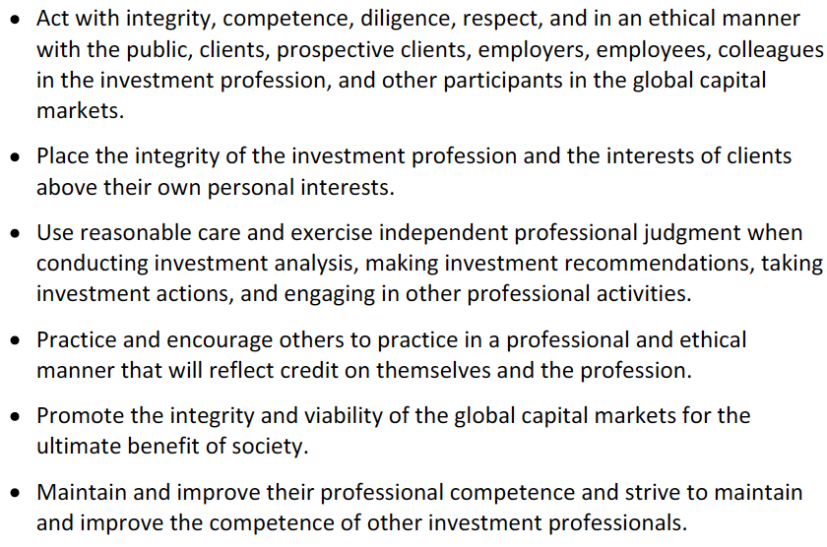

**The Standards of Professional Conduct**

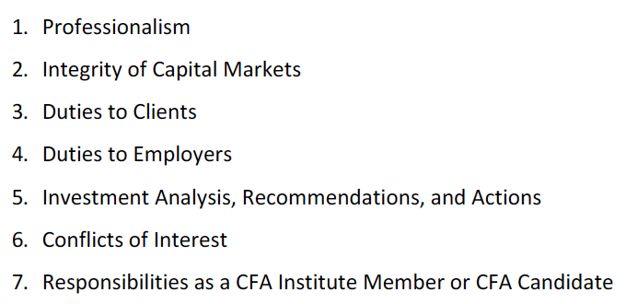

## Explain the ethical responsibilities required by the Code and Standards, including the sub-sections of each Standard

**STANDARDS OF PROFESSIONAL CONDUCT**

**I. Professionalism**

* **Knowledge of law**: understand and comply with all applicable laws, rules and regulations. In the case of a conflict, members must comply with the stricter law.
* **Independence and objectivity**: members must maintain independence and objectivity and not offer, solicit or accept any benefit that could compromise their independence and objectivity.
* **Misrepresentation**: members must not knowingly make any misrepresentations related to its professional activities.
* **Misconduct**: members must not engage in any professional conduct that involver dishonesty, fraud or deceit or commit any act that reflects adversely on their professional reputation, integrity or competence.

**II. Integrity of capital markets**

* **Material Nonpublic information**: when having in power material nonpublic information that could affect the value of an investment, members must not act or cause other to act on the information.
* **Market manipulation**: members must not engage practices that distort or artificially change prices and volume with the intent to mislead.

**III. Duties to clients**

* **Loyalty, prudence and care**: members must place clients’ interests before the employer’s or own interest. Towards their clients, a reasonable care and prudent judgement must be present.
* **Fair dealing**: members must deal fairly and objectively with all clients.
* **Suitability**: when in advisory relationship with clients, members must:
  + Make an inquiry to a client’s investment experience, risk and return objectives and financial constraints prior to making any recommendation (this information should be regularly updated).
  + Determine that an investment is suitable considering the client’s profile.
  + Judge suitability of investments in the context of the client’s total portfolio.

When managing a portfolio, investors should only make recommendations and take actions consistent with the stated objectives and constraints of the portfolio.

* **Performance presentation**: members must make reasonable efforts to ensure that the information is fair, accurate and complete.
* **Preservation of confidentiality**: Members must keep client’s information confidential unless the information concerns illegal activities on part of the client, is required by law or client allows it.

**IV. Duties to employers**

* **Loyalty**: in matters related to their employment, members must act for the benefit of their employer and not deprive him (divulge confidential information, take advantage of their skills and abilities).
* **Additional compensation arrangement**s: No benefits that could competes with or create a conflict of interest with their employers should be received, unless a written consent from all parties involved is obtained.
* **Responsibilities of supervisor**: Members must make a reasonable effort to ensure that anyone under their supervision complies with applicable laws, rules, regulation and the Code and Standards.

**V. Investment analysis, recommendation and actions**

* **Diligence and reasonable basis**: members must:
  + Exercise diligence, independence and thoroughness in its recommendations, decisions and analysis.
  + Have a reasonable, supported and adequate basis for any analysis, recommendation or action.
* **Communication with clients and prospective clients**: members must:
  + Disclose the basic format and general principles of the investment process used and disclose material changes.
  + Disclose significant limitations and risks of the investment process.
  + Disclose the factors (which must be identified with a reasonable jugement) that are important for the recommendation, analysis or action.
  + Clearly distinguish between facts and opinions.

**VI. Conflicts of interest**

* **Disclosure of conflicts**: embers must make full and fair disclosure (prominently, effectively and in plain language) that could impair their independence and objectivity or interfere with the duties to their client and employers.
* **Priority of transactions**: transactions for clients and employers must have priority over transactions where the member is the beneficial owner.
* **Referral fees**: members must disclose to employers and clients, as appropriate, any benefit received from or paid to others for the recommendation of products.

**VII. Responsibilities as a CFA Institute member of CFA candidate**

* **Conduct as participants in CFA Institute Programs**: members must not engage in any conduct that compromises the reputation or integrity of the CFA Institute or the CFA designation or the integrity, validity or security of the CFA Institute Programs.
* **Reference to CFA Institute, the CFA Designation and the CFA Program**: when referring to any of these, members must not misrepresent or exaggerate the meaning or implications of holding the membership, designation or candidacy.

# Reading 3: Guidance for Standards I-VII

## Demonstrate the application of the Code of Ethics and Standards of Professional Conduct on situations involving issues of professional integrity

## Distinguish between conduct that conforms to the Code and Standards and conduct the violates the Code and Standards

## Recommend practices and procedures designed to prevent violation of the Code and Standards



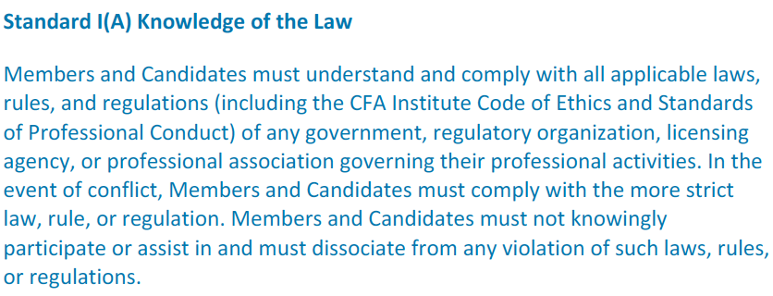

So, do not violate rules and regulations in the Code and Standards, the country where the member resides and the country where the member is doing business.

CFA Institute encourages to report potential violations of coworkers or clients with a supervisor or the compliance department. If it does not work, the member must dissociate from the activity and in an extreme case, from the firm.

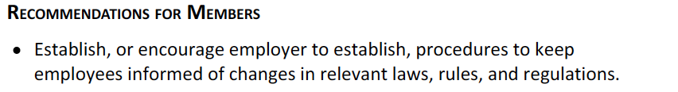

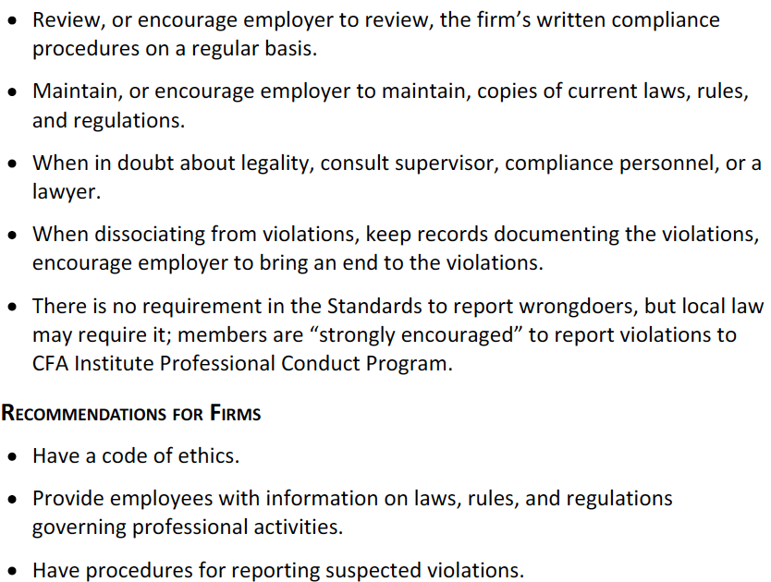

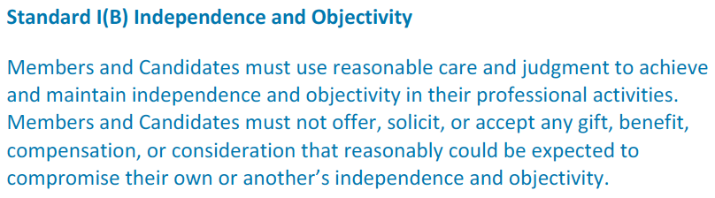

Allocating shares in oversubscribed IPOs to personal accounts is a violation.

Normal business entertainment is permitted but must not influence the member or others (when the member is the one that is offering).

Gifts from clients are considered less likely to compromise independence and objectivity but must be disclosed to the employer prior to acceptance if possible. If not, after acceptance.

Reports payed by the subject firm can be done only if the rate is not tied to the conclusions of the report and the fact that the research is issuer-paid must be disclosed.

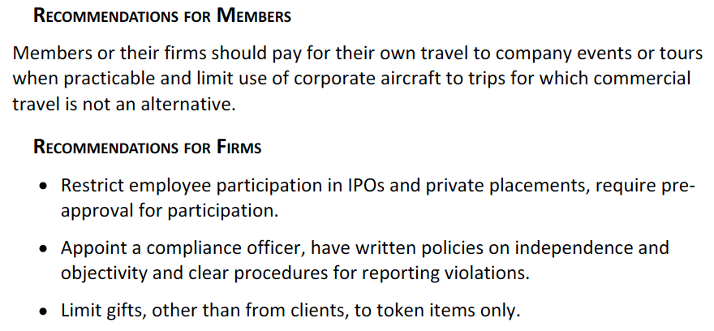

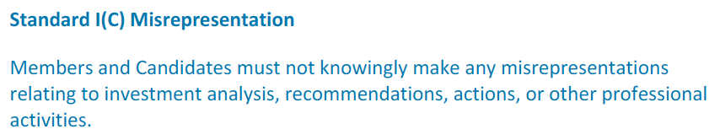

This includes knowingly mislead investors, omit relevant information, present selective data to mislead and plagiarism (crediting the source is not required when using studies from recognized financial and statistical reporting services).

When using inside peers’ models, their names should be included.

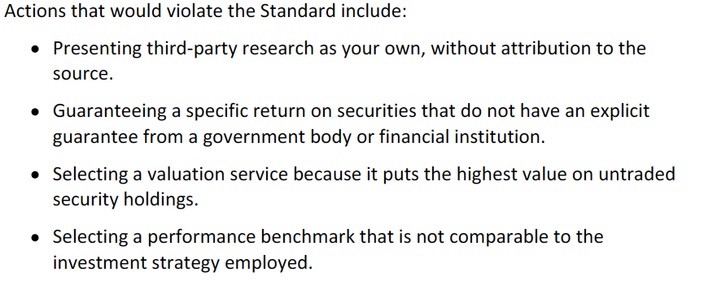

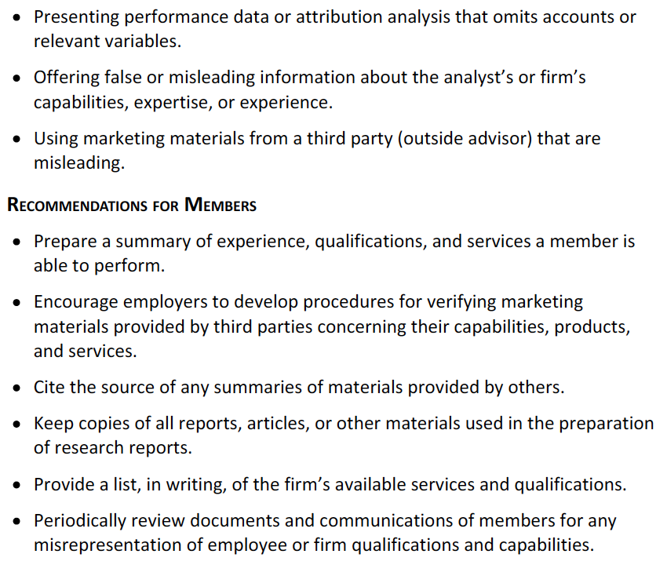

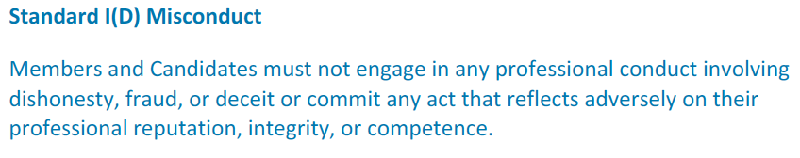

The Standards must not be used against another member to settle personal, political or any other dispute unrelated to professional ethics or competence.

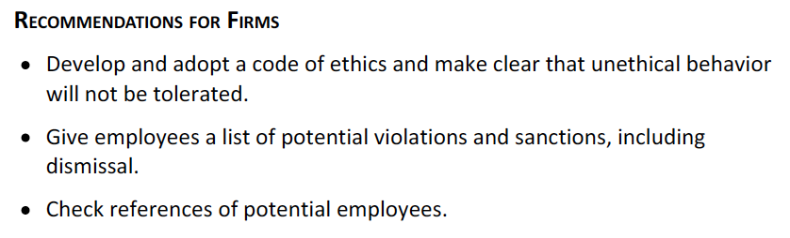

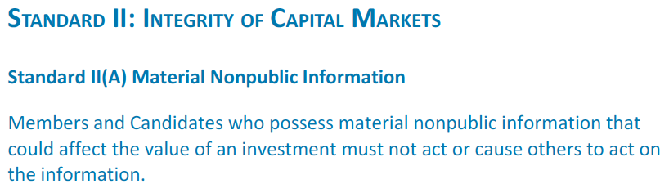

Information is material it its disclosure would affect the price of a security. Information that is ambiguous to its likely effect on price may not be considered material.

Information is nonpublic until it has been made available to the marketplace. An analyst conference call is not a public disclosure.

In investment banking, for instance, the information disclosed by the client should only be used for its intended purpose.

Mosaic theory -> reaching an investment conclusion through perceptive analysis of public information combined with non-material nonpublic information is not a violation of the Standard.

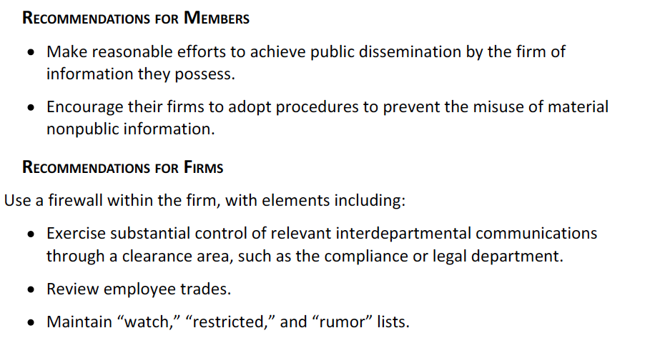

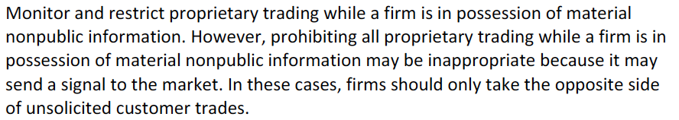

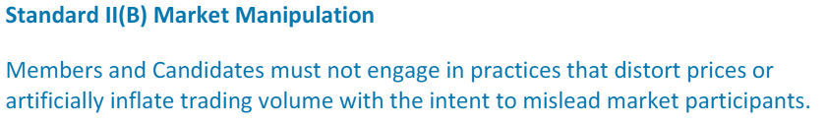

The key point is the intent to mislead. Spreading false information is clearly a fault.

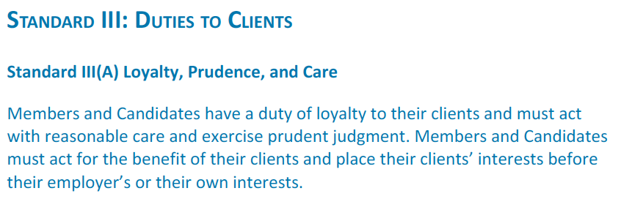

Client interest always come first.

Members must:

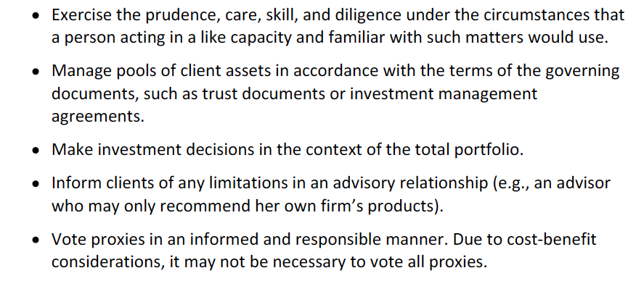

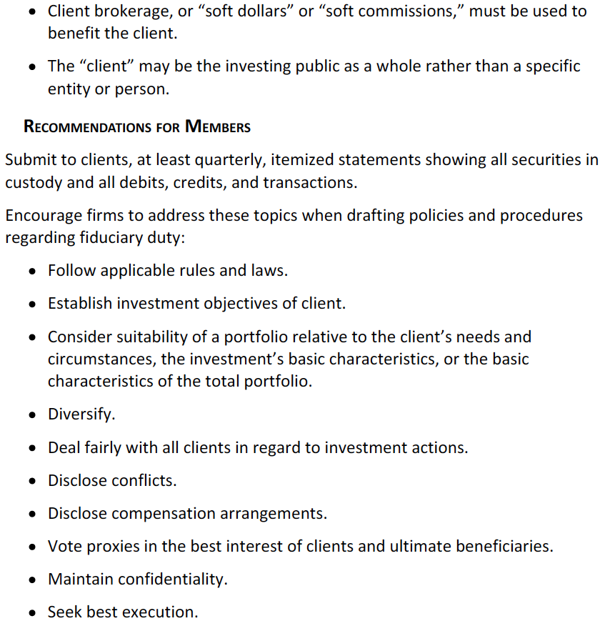

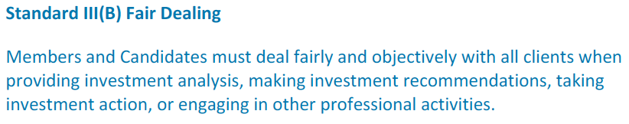

Do not discriminate against any client and remember that fairly is not the same as equally.

Different service levels are acceptable but must not negatively affect the client and must be disclosed to all clients.

When there is an opportunity, every client must be aware of it before an order for the security is accepted.

Institutional and individual investors must be treated impartially and fairly.

The member must not take advantage of his position to disadvantage clients.

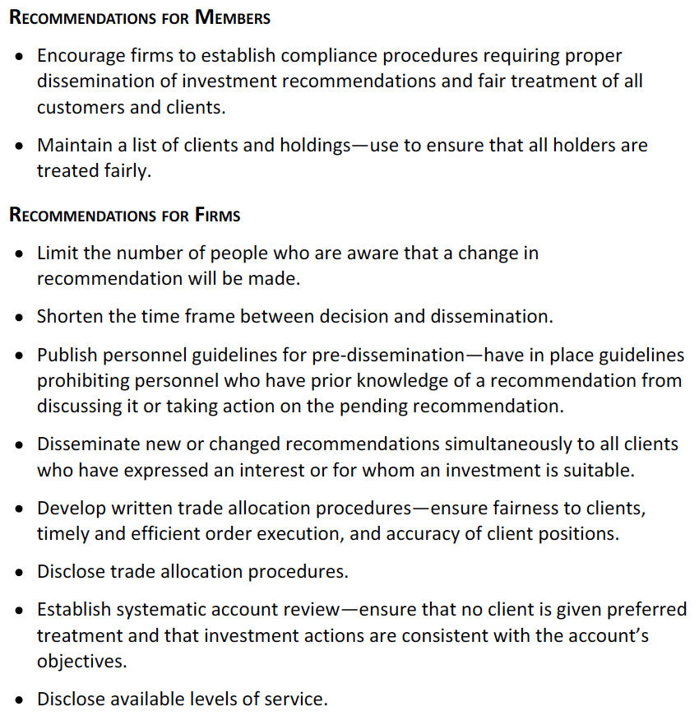

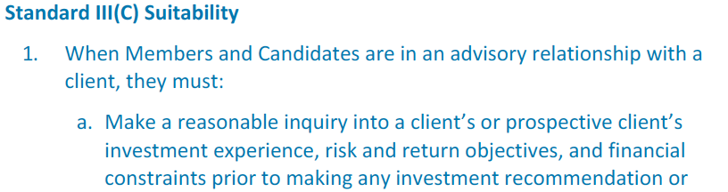

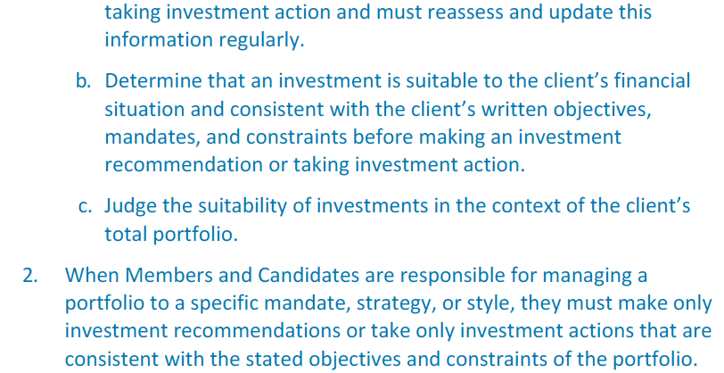

In advisory relationships, members must gather client information at the beginning in the form of an IPS.

When managing a fund, he must select investments consistent with the stated mandate.

Trades that are ordered by the client but unsuitable in accordance to the IPS must be discussed with the client and the reasons of why it is unsuitable must be disclosed.

If the effect on risk/return is minimal, the trade may be done by following the firm’s policies. If the effect is material, one option is to change the IPS. If the client does not accept to change the IPS, if the firm’s policy allows it, the trade can be made in a separate client-directed account. If there are no more options, the manager may need to reconsider whether maintaining the relationship with the client.



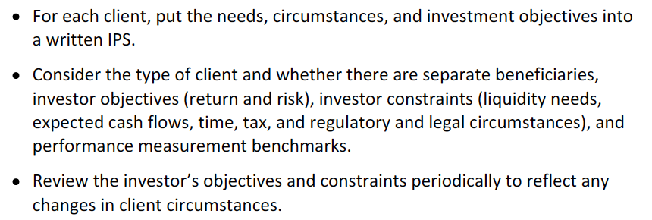

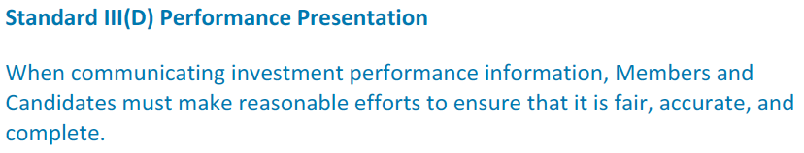

It must not be stated that a rate of return similar to the achieved in the past will be reached.

When the presentation is intended to be short, the member must point out that the presentation offered limited information.

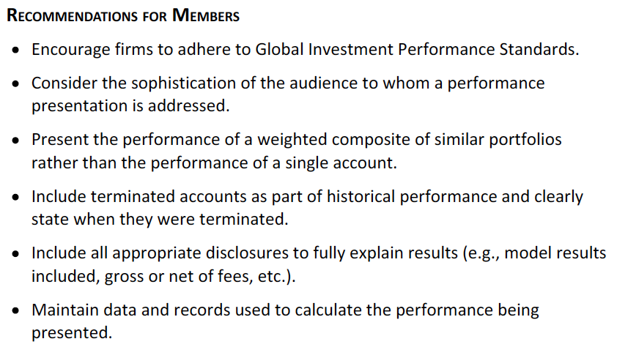

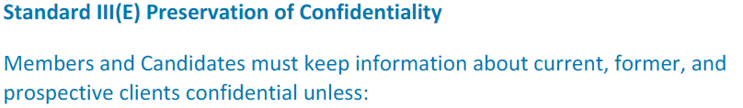

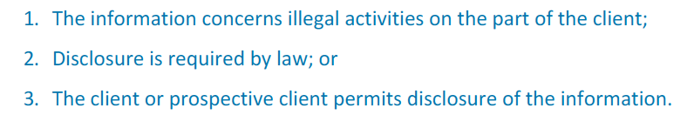

If illegal activities by a client are involved, members must report it to the authorities.

Confidentiality extends to form clients to.

Members should still cooperate with a CFA Institute Professional Conduct Program (PCP) investigation.

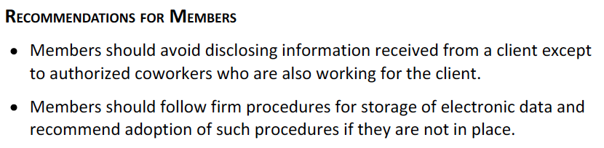

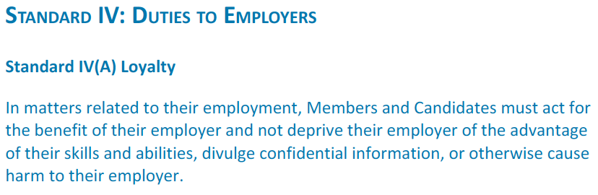

If members are independent, the have a duty to abide by the terms of their agreements.

Members should always place client interest above interests of their employer but consider the effects of their actions on firm integrity and sustainability.

There is no need to put employer interests over family and personal obligations.

Independent practice can be done with the consent of the employer, so a description of the services to be offered, compensation, duration and nature of the activities must be explained to the employer.

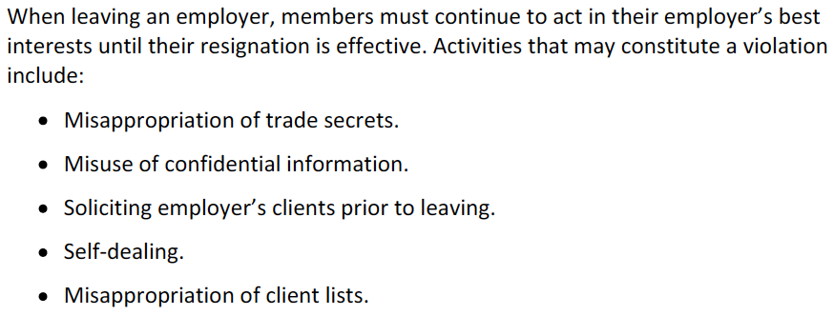

When leaving the firm, the employee can keep simple knowledge of names and existence of former clients, use the experience or knowledge gain with the former employer and act in favor of any agreement that was made with the former employer.

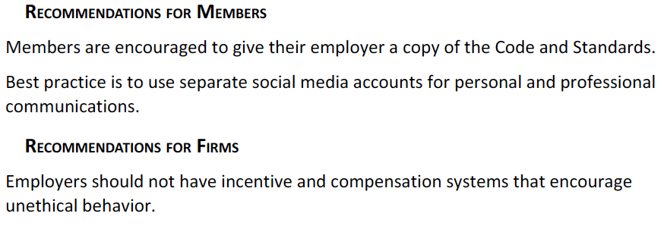

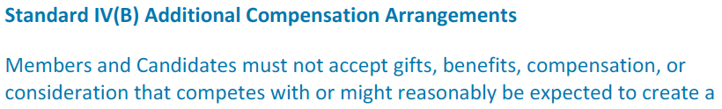



Compensation includes direct and indirect compensation from a client and other benefits received from third parties.

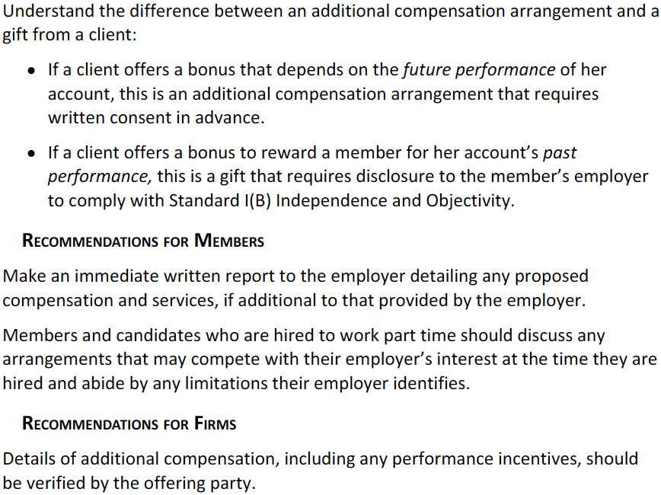

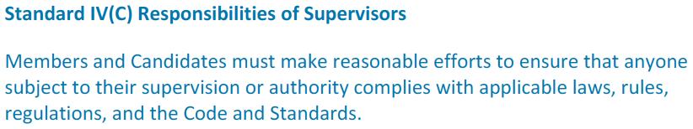

Prevention and detection efforts must be made.

Compliance systems must meet industry standards, regulatory requirements and the requirements of the Code and Standards. If the compliance system is inadequate, the member has the obligation to notify his manager. If they are not change, the member should decline supervisory responsibility.

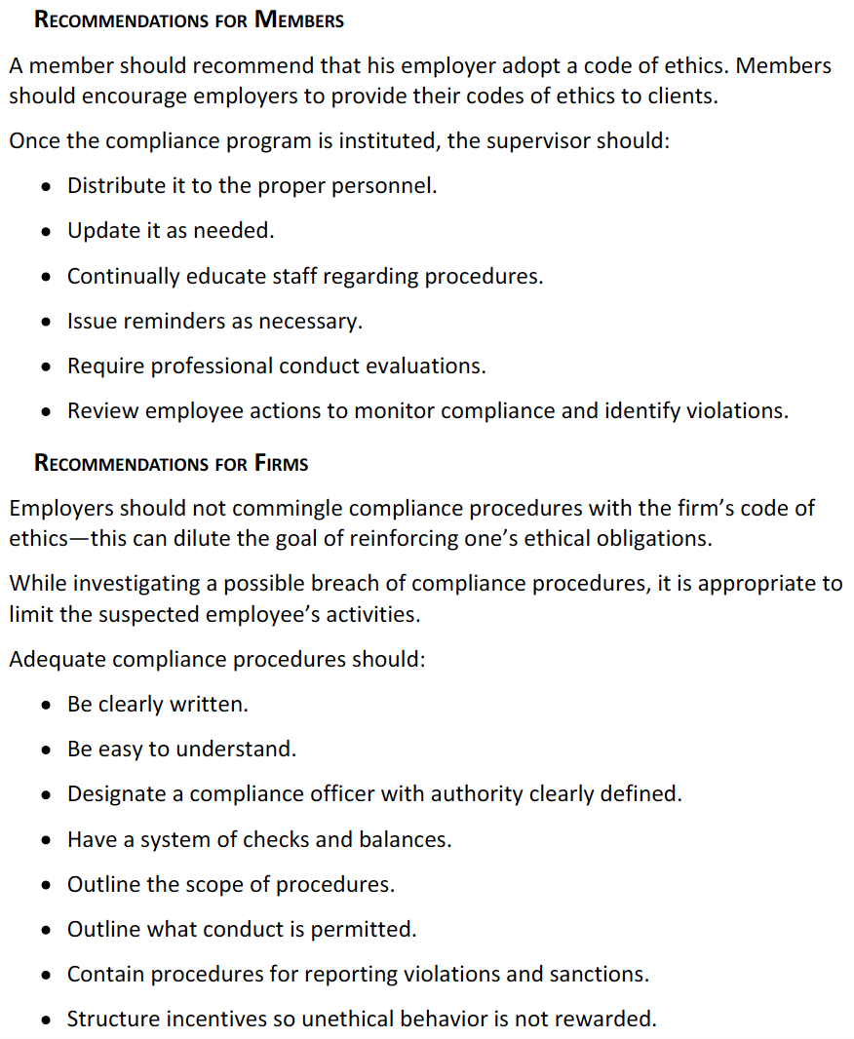



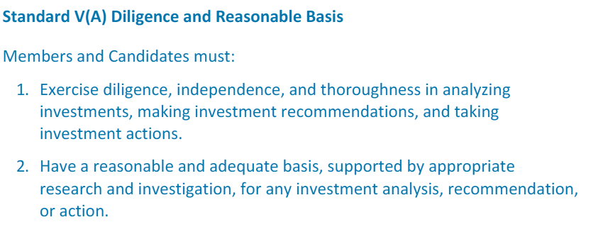

The degree of diligence, thoroughness of research and the level of investigation depends on the investment philosophy adhere to, member’s roles in the investment decision-making prices and the resources and support provided by employers. Also, it will depend on the product or service offered.

Things to consider prior to making a recommendation or taking decisions:

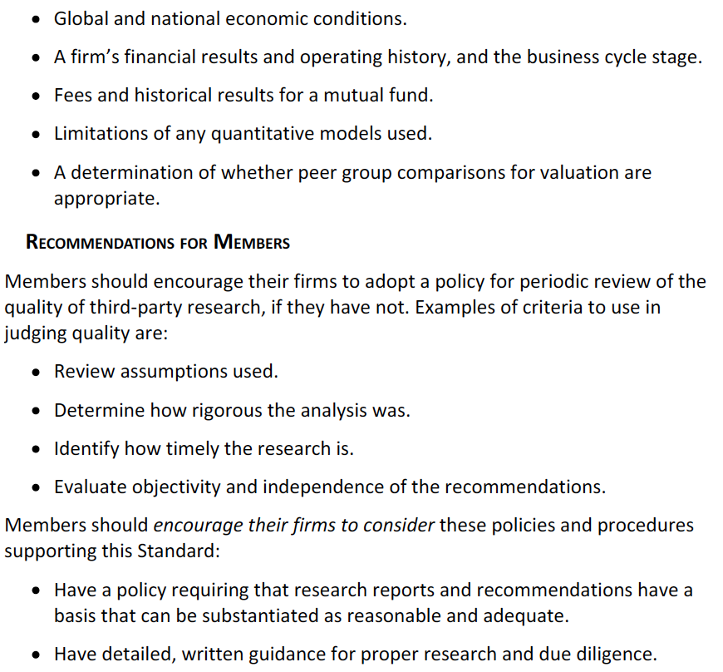





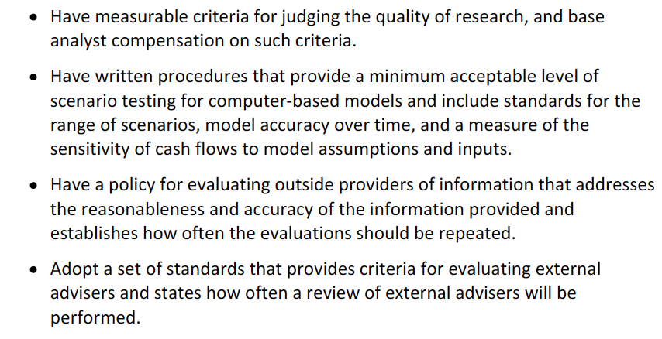

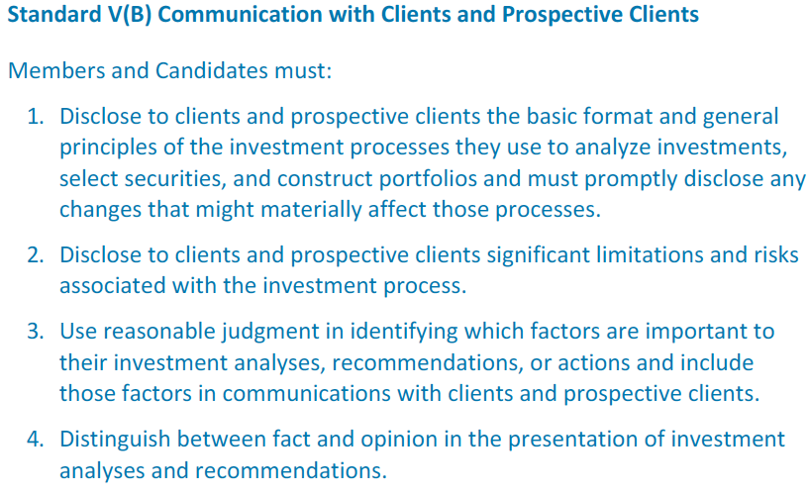

This Standard refers to all means and types of communication.

When using projections, members can violate the Standard by not explaining the limitations of the models and assumptions used.

Investment limitations (liquidity, capacity (refers to the investment vehicle’s ability to absorb additional investment without reducing the returns it is able to achieve)…) must be disclosed.

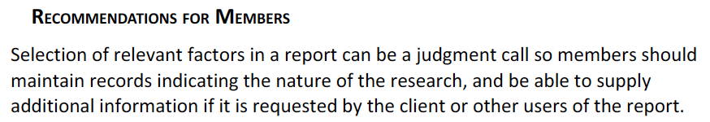

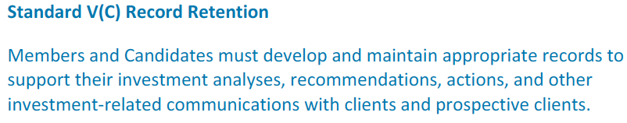

Records that support conclusions and actions must be hold by the member and are property of the firm.

All communications with clients must be retained.

When changing of employer, the member must not rely on memory or materials created at his previous firm.

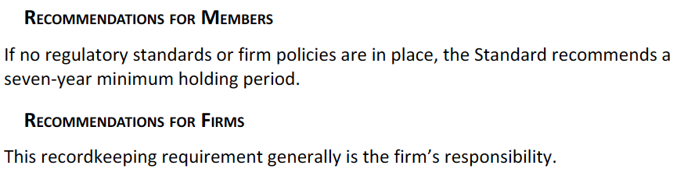



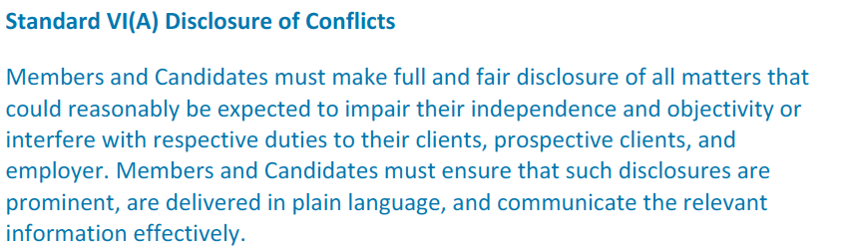

Actual ownership on the analyzed stock, board service and broker-dealer market-making activities are some of the disclosures that must be included.

Compensation structure should also be disclosed whenever it might create a conflict of interests.

Conflicts must be promptly reported to the employer.

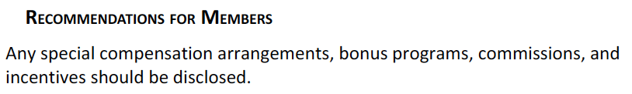

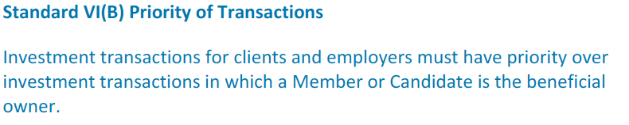

Also take priority over transactions made on behalf of the member’s firm. Personal transactions go after the client and the employer have had an adequate opportunity to act on a recommendation.

Family member with client account = any other client account.

Members must not act on information about pending trades for personal gain.

When requested, members must fully disclose to investors their firm’s personal trading policies.

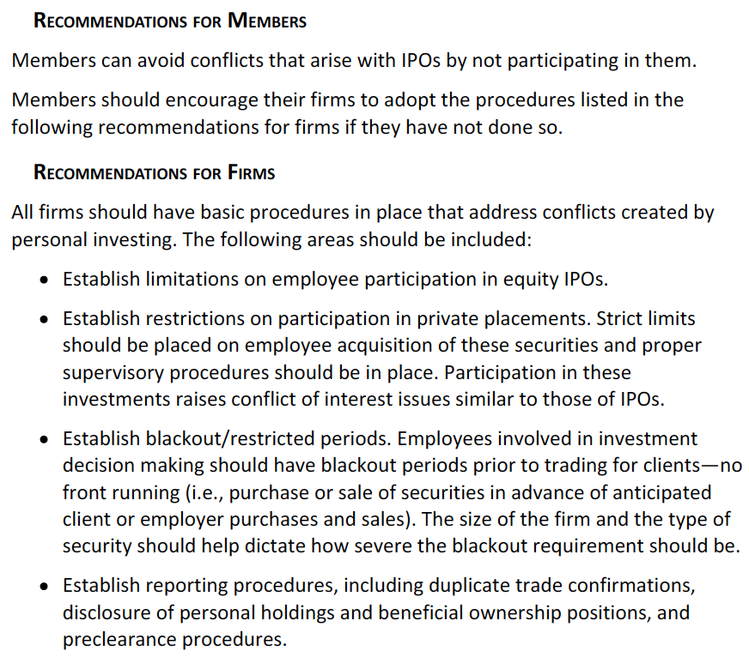

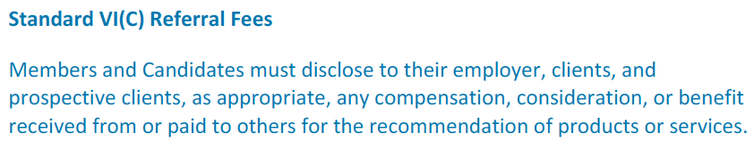

Members must inform this so that a full cost evaluation of the recommendation can be done.

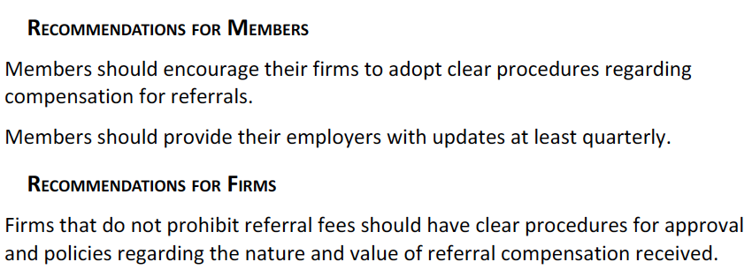

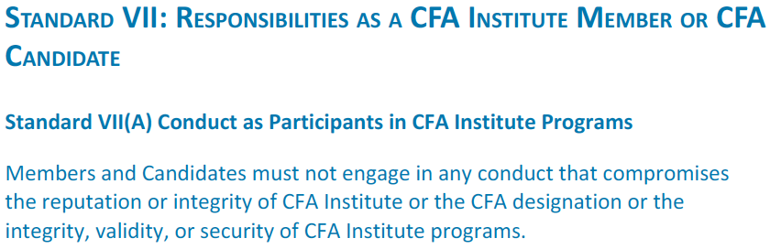

Conducts that must be avoided:

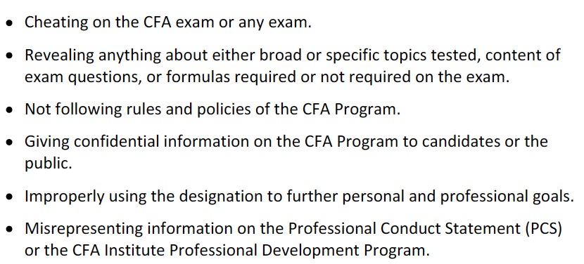

Members can vie opinions but not share confidential information.

Members who volunteer may not solicit or reveal information about questions of the exam, the grading process or scoring of questions.

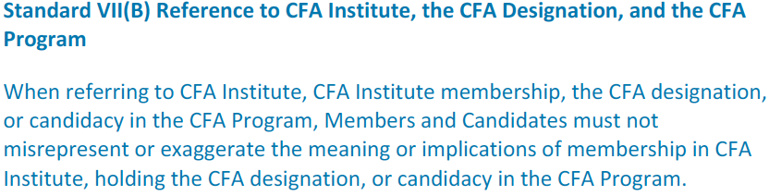

Members must not make promotional promises tied to the designation (like promising over-promising competence or investment results.

To maintain membership, members must:

* Sign the PCS annually.
* Pay CFA institute membership dues annually.

Chartered Financial Analyst and CFA marks must always used either after the name or as adjectives, never as nouns. It cannot be used in pseudonyms.

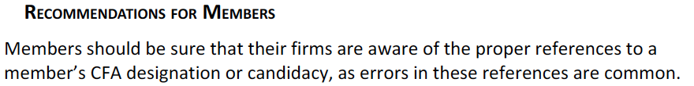

# Reading 4: Introduction to the Global Investment Performance Standards (GIPS)

Compliance with GIPS is voluntary.

## Explain why the GIPS standards were created, what parties the GIPS standards apply to and who is served by the standards

At the past, reporting procedures included misleading practices, including:

* Representative accounts – showing a top-performing portfolio as representative of the firm’s results.
* Survivorship bias – excluding weak performing account that have been terminated.
* Varying time periods – showing performance of only certain periods of time with outstanding results.

GIPS – set of ethical principles based on a standardized, industry-wide approach. These standards seek to avoid mispresentations of performance.

They allow for clients to more easily compare performance.

## Explain the construction and purpose of a composites in performance reporting

Composite – grouping of individual portfolios representing similar investment strategy, objective or mandate. Are recommended.

Portfolios should be assigned to each composite before they begin to perform, to avoid any performance bias when assigning the portfolio.

## Explain the requirements for verification

Verification is performed by a third party

Requirements:

* The firm complies with all GIPS requirements for composite construction on a firm-wide basis.
* The firm’s processes and procedures are established to present performance in accordance to the calculation methodology, data requirements and format required by GIPS.

Recommendations:

* Pursue independent verification.
* Verified firms should include the following disclosure language: “firm x has been verified for the period y and z by verifier w. A copy of the verification report is available upon request.”

# Reading 5: The GIPS Standards

## Describe the key features of the GIPS standards and the fundamentals of compliance

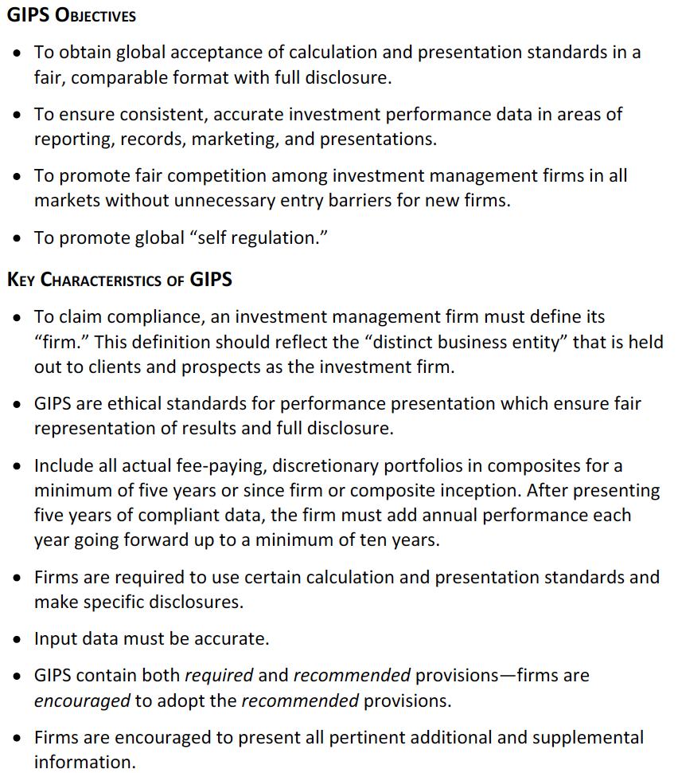

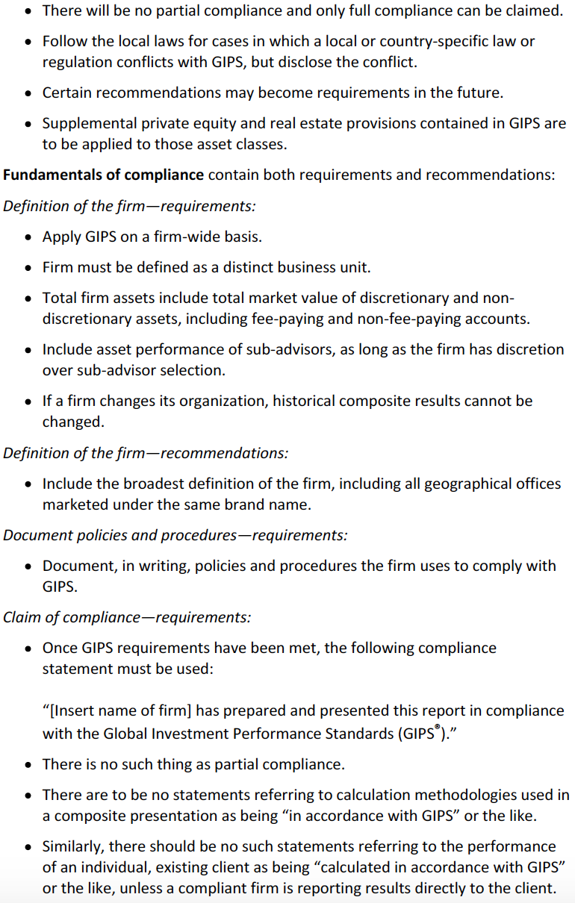

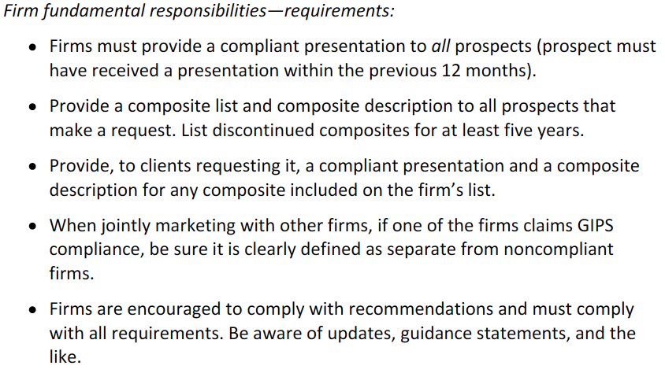

## Describe the scope of the GIPS standards with respect to an investment firm’s definition and historical performance record

Definition of the firm = corporation, subsidiary or division that is held out to clients as a business entity. If it has different geographic location, it includes its locations and clients.

I don’t understand this:

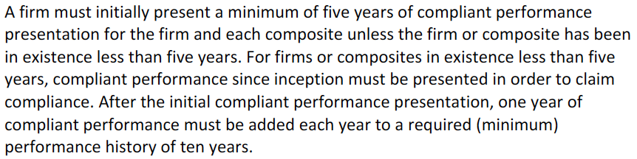

Firm may present noncompliant performance immediately after presenting compliant performance.

## Explain how the GIPS standards are implemented in countries with existing standards for performance reporting and describe the appropriate response when the GIPS standards and local regulations conflict

Before 2006, CVG compliant results may claim GIPS compliance. I do not understand the thing with the ten years.

If regulations have conflict with GIPS, the firm must follow regulation and disclose the nature of the conflict with GIPS.

## Describe the nine major sections of the GIPS standards

**0. Fundamentals of compliance:** comply with:

* Definition of the firm.
* Documentation of the firm policies and procedures with respect to GIPS compliance.
* Complying with GIPS updates.
* Claiming compliance in the appropriate manner.
* Appropriate verification treatment when a third-party verifier is employed.

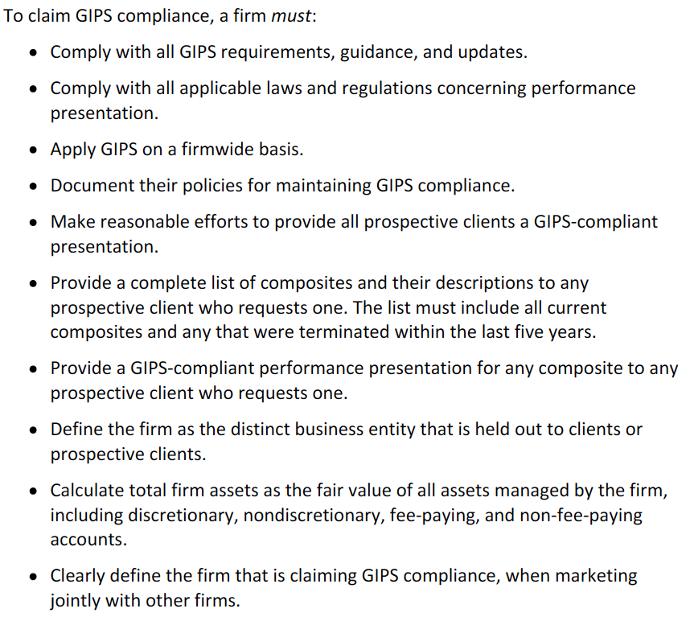

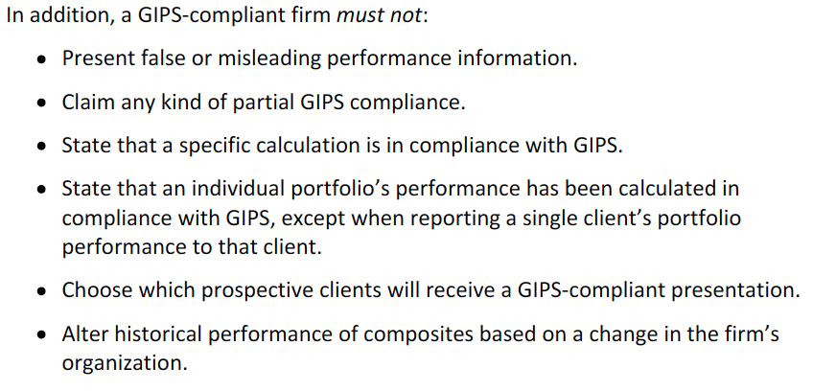

**1. Input data:** should be consistent in order to establish full, fair and comparable investment performance presentations.

**2. Calculation methodology:** uniformity and compliance with the methodologies of the GIPS is required.

**3. Composite construction:** creation of meaningful, asset-weighted composites.

**4. Disclosures:** the firm must disclose information about the presentation and the policies adopted by the firm so that the raw numbers presented in the report are understandable to the user.

**5. Presentation and reporting:** must be according to GIPS requirements and include extra information when appropriate.

**6. Real estate:** certain provisions apply to this type of investments.

**7. Private equity:** must be valued according to GIPS.

**8. Wrap fee/ Separately managed account (SMA) portfolios:** for these portfolios, some requirements in section 0 through 5 are replaced.